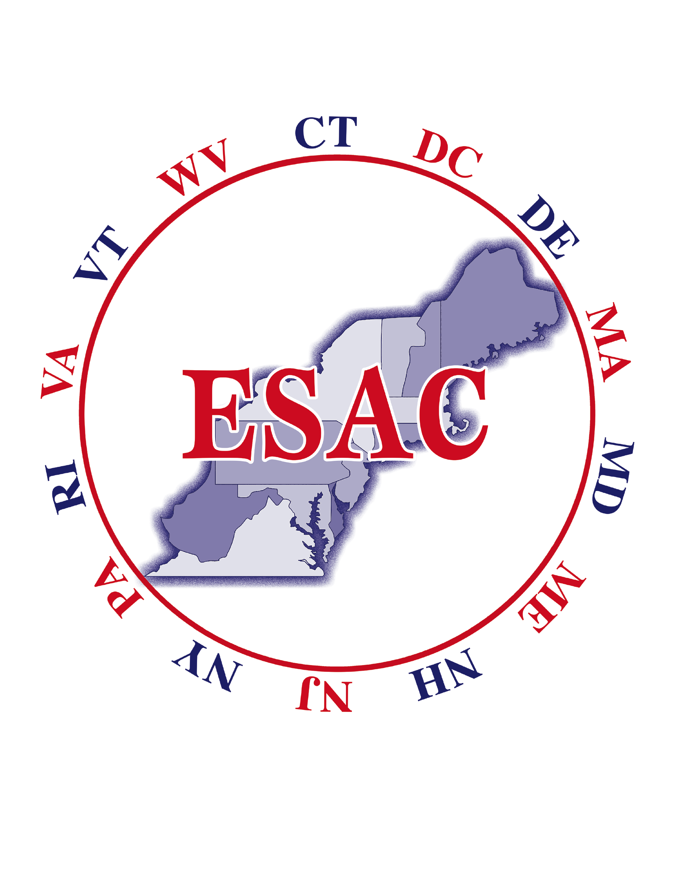
ESAC 2019
Eastern Seaboard Apprenticeship Conference
Westin Portland Harborview Hotel – Portland, Maine
www.esaconference.org

Dear Member of the Apprenticeship Community:

You are cordially invited to attend this year’s annual conference May 20-24, 2019 at the Westin Portland Harborview in Portland, ME. This is the 75th year the apprenticeship community has come together to share information and ideas regarding registered apprenticeship. Representatives from the Labor, Management, Federal Government, State Government, educational facilities and small and large businesses will be attending this longest running Apprenticeship Conference in the U.S.

The conference will kick off with an evening reception on Monday, May 20th. Single plenary educational sessions/workshops will begin on Tuesday, May 21st and conclude on Friday, May 24th. The annual luncheon will be held on Tuesday, May 21st and sponsored receptions have been planned on various nights during the week. There are many attractions at the resort available for spouses to explore. (Please visit website for more information). A full schedule of the conference as well as activities will be posted on the website –www.esaconference.org www.esaconf.orgby mid March.

In order to reserve your hotel room, contact The Westin Portland Harbor Hotel at (855) 511-0043 and ask for the ESAC conference rate or follow this direct link, https://www.starwoodmeeting.com/Book/ESAC2019, to receive the ESAC discounted group rate of $135/night. We encourage you to arrive early or stay an extra day to take advantage of the area activities and fine restaurants! Please make your reservation early to guarantee the group rate.

Please send your conference registration soon to take advantage of the early bird special, so that we may plan for an outstanding Conference.

We look forward to seeing you in Portland, Maine!

Sincerely,

Bill Paul
Bill Macchione, President Paul Costello, Secretary/Treasurer

CONFERENCE EXHIBITOR FORM
May 20th – 24th, 2019
Westin Portland Harborview Hotel – Portland, ME
www.esaconference.org

We are pleased to provide exhibit space for ESAC 2019 at The Westin Portland Harborview Hotel in Portland, ME May 20-24, 2019. Each exhibitor will have access to an 8’ X 10’ area for the conference duration for a minimal fee of $600. This fee includes admittance to all the conference events for one person.

If you wish to exhibit at ESAC 2019, please complete the form below and forward with payment to:

ESAC Conference Office
ESAC 2019 – Exhibitor
28 Pelham Street
Newport, RI 02840

Once the exhibitors form and payment are received, you will be contacted with further information regarding locations and setup needs.

NAME:________________________________________________________________

COMPANY/ORGANIZATION: _____________________________________________

ADDRESS:_____________________________________________________________
STREET CITY STATE ZIP

PHONE #: _________________FAX:_________________E-MAIL:________________

_____________________________________________________________________

METHOD OF PAYMENT:  Check  AMEX/VISA/MC

CREDIT CARD: __ __ __ __- __ __ __ __-__ __ __ __-__ __ __ __

EXPIRATION DATE: _________SECURITY CODE: _______

**Please make checks payable to ESAC 2019**
OR mail/fax in with your credit card information to (401) 846-5600 or you may scan and email to: hannahnewportevents@gmail.com
ESAC Show Office, 28 Pelham Street
Newport, RI 02840, (401) 847-7666
CONFERENCE SPONSORSHIP FORM
May 20th – 24th, 2019
Westin Portland Harborview Hotel – Portland, ME
www.esaconference.org

We are pleased to announce sponsorship opportunities for the 2019 Eastern
Seaboard Apprenticeship Conference (ESAC). ESAC is made up of apprenticeship representatives from 14 Atlantic coast states and the District of Columbia. ESAC
is expected to attract about 400 conferees to The Westin Portland Harborview Hotel, Portland, Maine, May 20th – 24th, 2019.

To make ESAC more affordable than the average conference, we seek contributions to defray the costs of receptions, luncheons, conference paraphernalia and printing. We respectfully request that your organization sponsor or co-sponsor an event to help us make this Westin Portland Harborview Hotel conference the best ESAC ever! Co-sponsoring is a cost effective way to show support and yet share the costs with other locals or organizations to get the message of apprenticeship solidarity across loud and clear.

EVENT COST
Breakfast $ 3,500
Continental Breakfast $ 1,500
Breaks (Per Break) $ 1,500
Annual Luncheon - Tuesday $ 10,000
Receptions (Each) – Tuesday and Wednesday $ 5,000 (Co sponsorship)
Registration Bags $ 1,800
Special Reception - Monday $ 5,000 (First night location tbd)

Event sponsors will be given an opportunity to speak before the function and due credit will be given in the program booklet as well as signs indicating the sponsor for that particular event. We encourage you to take advantage of this wonderful opportunity to showcase your program or organization. Remember that all these events can be
co-sponsored and that any contribution will help to make this a great conference!

ESAC 2019

NAME: _________________________________________________________________

COMPANY/ORGANIZATION:______________________________________________

ADDRESS: ______________________________________________________________

STREET/CITY, STATE/ZIP: ___________________________________________________

PHONE #: _________________FAX: _________________EMAIL:____________________
METHOD OF PAYMENT: ❒ Check ❒ AMEX/VISA/MC

CC #: __ __ __ __- __ __ __ __-__ __ __ __-__ __ __ __ EXP.: ______ CV CODE: ____
**Please make checks payable to ESAC 2019**
OR mail/fax in with your credit card information to (401) 846-5600 or you may scan and Email to: hannahnewportevents@gmail.com
ESAC Show Office, 28 Pelham Street, Newport, RI 02840 (401) 847-7666
CONFERENCE PROGRAM FORM
May 20th – 24th, 2019
Westin Portland Harborview Hotel – Portland, ME
www.esaconference.org

ESAC 2019 CONFERENCE PROGRAM SPONSORSHIP
ESAC 2019 promises to be a very unique and exciting conference for its participants. In an effort to keep registration costs down, the ESAC Planning Committee is seeking your financial assistance to realize our goals. A traditional medium for apprenticeship programs, labor organizations, contractors and government agencies to advertise their specialties is the sponsorship pages in the conference ad book, which is also a great way to show support of ESAC! Submit your advertisement now. Do not miss this wonderful opportunity to greet your colleagues, to showcase your programs and to celebrate ESAC 2019!

☐ FULL PAGE $ 350 ☐ FULL BACK COVER/ COLOR $1,000

☐ ONE-HALF PAGE $ 200 ☐ MIDDLE GOLD PAGE $600

☐ INSIDE FRONT/BACK $600 ☐ SAME AS LAST YEAR
COVER IN COLOR

NAME: _________________________________________________________________

COMPANY/ORGANIZATION:______________________________________________

ADDRESS: ______________________________________________________________ STREET CITY STATE ZIP
PHONE#: _________________FAX:_________________EMAIL:__________________

METHOD OF PAYMENT:  Check      AMEX/VISA/MC

CC #: __ __ __ __- __ __ __ __-__ __ __ __-__ __ __ __ EXP.: ________CV CODE: _______
**Please make checks payable to ESAC 2019**
OR mail/fax in with your credit card information to (401) 846-5600.
Please email/scan your camera-ready advertisement to hannahnewportevents@gmail.com
and remit payment to the following address by May 2nd, 2019 to:

ESAC Show Office
ESAC 2019 – AD BOOK
28 Pelham Street
Newport, RI 02840
(401) 847-7666
CONFERENCE REGISTRATION FORM
May 20th – 24th, 2019
Westin Portland Harborview Hotel – Portland, ME
www.esaconference.org
You may register on-line or fill out the form below

Please Check the Appropriate ESAC 2019 Registration Option:

Early Bird Special – Full Conference Registration Fee $395.00_____
MUST BE RECEIVED PRIOR TO OR ON May 2nd, 2019
(Includes all Conference Materials and Sponsored Activities)

Regular Full Conference Registration Fee Received after May 2nd, 2019 $425.00_____
(Includes all Conference Materials and Sponsored Activities)

Single Day (Tuesday, Wednesday, Thursday) $145.00_____
(Includes all Conference Materials and Sponsored Activities)

Registration Fee for Guest / Spouse $215.00_____
(Includes all Sponsored Activities)

NAME: _____________________________________________________________________

TITLE: _____________________________________________________________________

ORGANIZATION: _______________________________________________________________

ADDRESS: _____________________________________________________________________
STREET CITY STATE ZIP

PHONE #: _________________FAX:_________________E-MAIL:_______________________

METHOD OF PAYMENT:  Check  AMEX/VISA/MC

CC #: __ __ __ __- __ __ __ __-__ __ __ __-__ __ __ __ EXP.: _________CV CODE: ________
**Please make checks payable to ESAC 2019**
There are no refunds on conference registrations
Please mail completed registration form and payment to:
ESAC Show Office
28 Pelham Street, Newport, RI 02840 (401) 847-7666
OR fax to (401) 846-5600. CONFERENCE REGISTRATION DOES NOT INCLUDE HOTEL RESERVATIONS. PLEASE MAKE YOUR HOTEL RESERVATION DIRECTLY WITH
The Westin Portland Harborview Hotel at (855) 511-0043 or this link, https://www.starwoodmeeting.com/Book/ESAC2019, and ask for the group discount.

